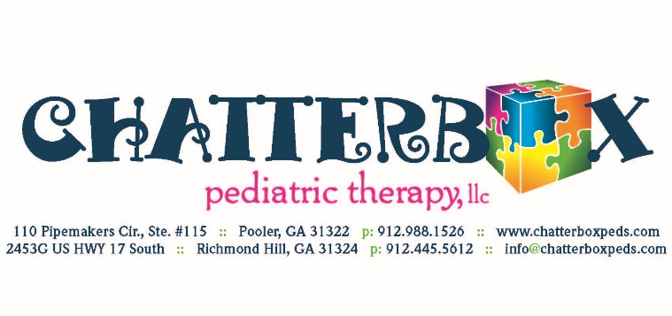
Photo/Video Release Form

At Chatterbox Pediatric Therapy, we love to celebrate the milestones reached by the children we treat as well as all the fun we have at work! Please note that we will not post any photos or videos of your child unless written permission is given by signing the form below.

I, _____________________________, the parent or legal guardian of _____________________________ [Child] grant _____________________________ Chatterbox Pediatric Therapy my permission to use the photographs taken during therapy
for any legal use, including but not limited to publicity, copyright purposes, illustration, advertising, and web content.

Furthermore, I understand that no royalty, fee, or other compensation shall become payable to me by reason of such use.

Parent/Guardian’s Signature: ___________________________ Date ________
Parent/Guardian’s Name: _________________________________________
Child’s Name: _________________________________________
Phone Number: _________________________________________

